Directions For Getting Started With Subsplash Giving

Visit this link- Subsplash Giving
You will see the following image. Please click “Login or sign up” in the upper right hand corner.
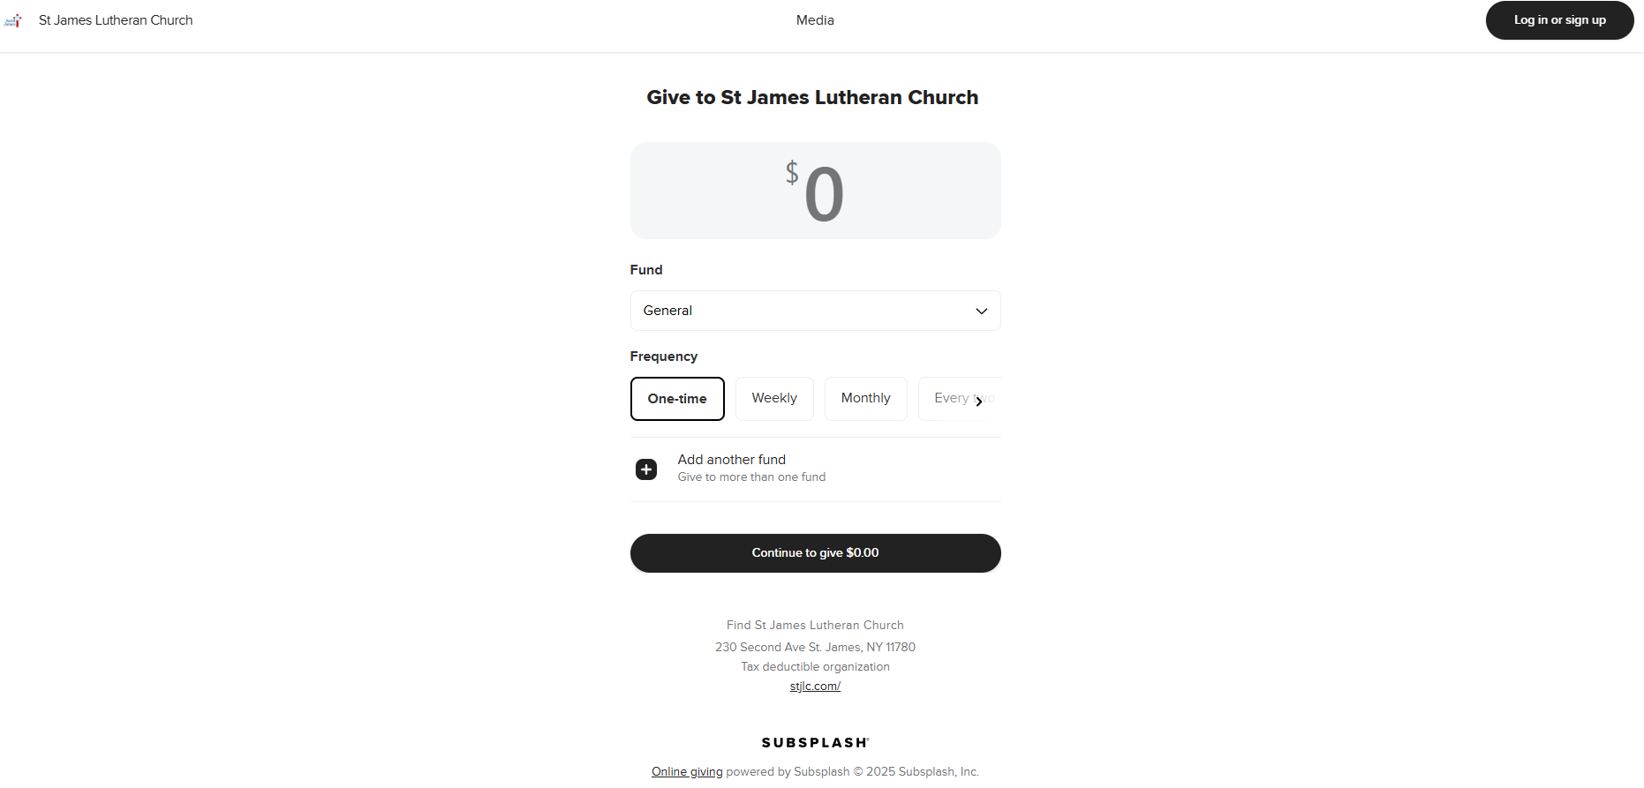

Next you will see this screen…Please again click on “Log in or sign up”
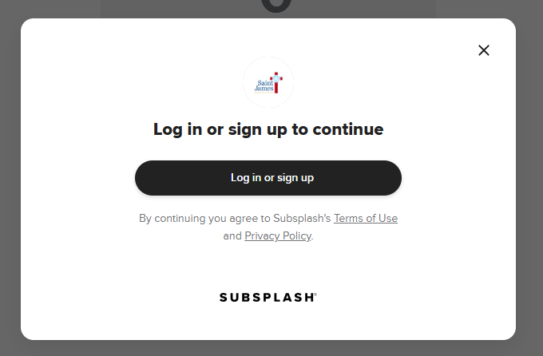

The Next screen you see is the login screen. Please click “Create an account”

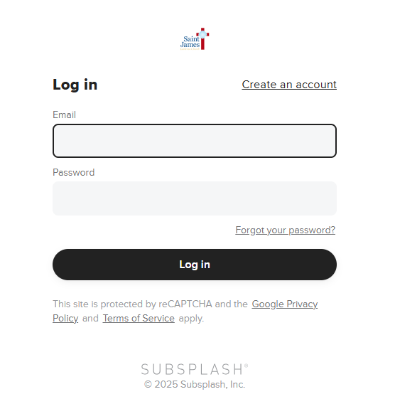

On this screen, please fill out your first name, last name, email address and what you would like your password to be. Then Click “Create Account”
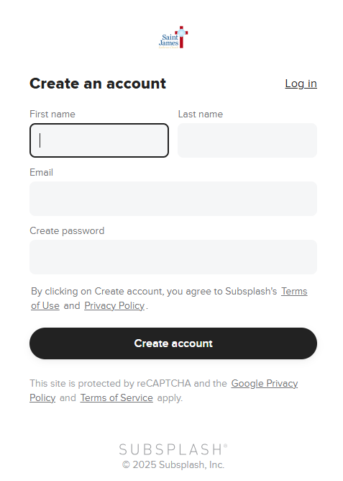

You will see this screen…
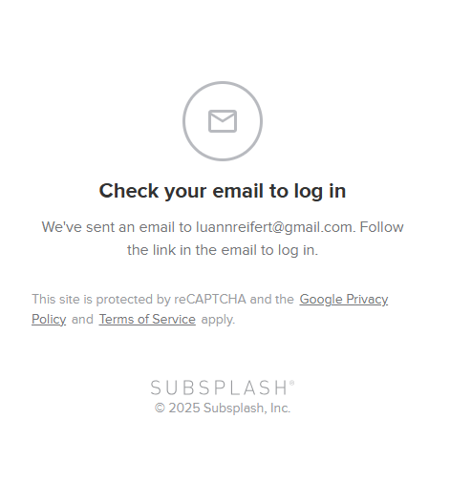

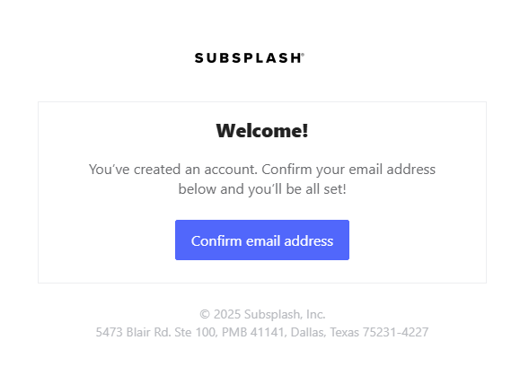
Head on over to your email and look for the email from subsplash that says “Welcome! You’ve created an account” Open the email and click on “Confirm Email Address” as seen below.

This screen bleow means you have successfully created your account. Click “continue” and log in to your newly created subsplash account.

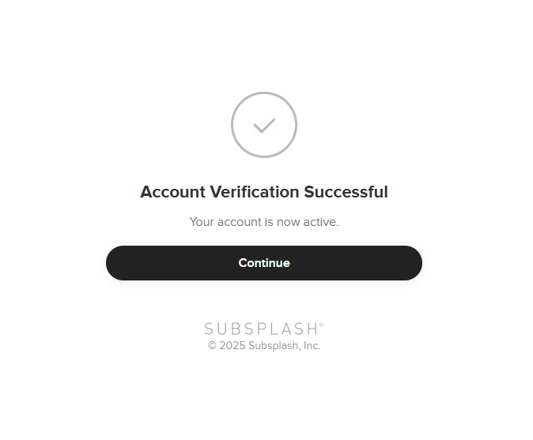

Log in with the email address and password you signed up with. You will then see the following screen. On this screen you may edit your profile information, and setup your giving/manage payment methods.
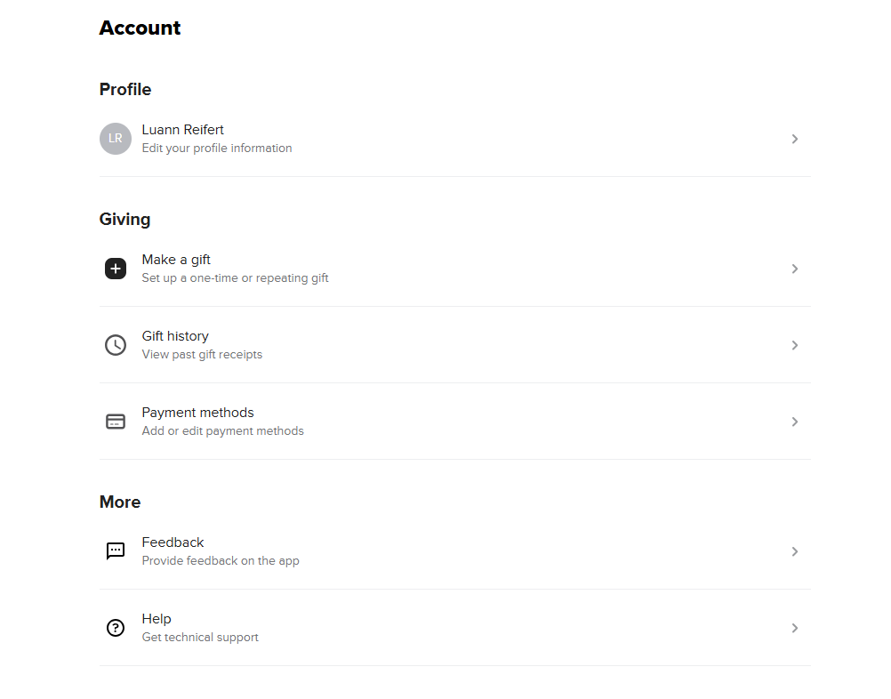
Once this is completed, you may login to Vanco (Our old Giving platform) and stop your payments there. The link can be found below our on our giving page at stjlc.com. Please click on this link to login into your vanco account and modify your giving.
My Vanco
If you need any help please call the office at 631-584-5212 or email Luann at luann@stjlc.com. We would be happy to set up an appointment with you to help get you started!

