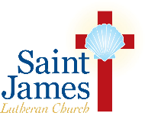
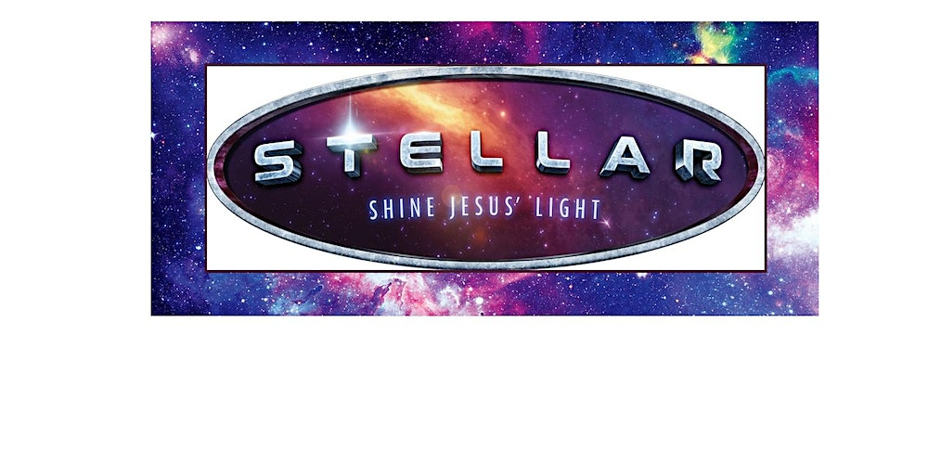
VBS Teen Program 2023
For teens who have completed 6th or 7th Grade as of June 2023

$45 per teen
August 7-11, 2023
9am-12:15pm

Welcome to Stellar – Shine Jesus’ Light!! Each day your teens will be part of fun Bible learning that speaks to their lives right where they are at! Teens get to help with Bible point crafts, team building games, lively Bible songs, and tasty treats - just a few of the activities that help teens and the children they interact with celebrate God’s love for them!
What is the teen program?
The teen program is a wonderful opportunity for teens to build relationships with each other and with God. They will also be learning the same Bible truths each day, and growing in their faith towards God and fellowship towards one another! Teens will also be eligible to earn Community Service hours based on their participation this week.
Requirements:
- Have a positive attitude towards serving, learning, and having fun!

- Follow all rules and guidelines as determined by VBS staff.

STJLC Teen VBS 2023 – Registration Form
Teen’s Name: ______________________________________________
Street Address: _____________________________________________
_____________________________________________
Mobile/Home Phone: _______________________________________
Email: ____________________________________________________
Teen’s Date of Birth (MM/DD/YYYY): _______________________
Allergies: __________________________________________________
Emergency Contact Name: ___________________________________
Emergency Contact Phone: ___________________________________
If you’d like to request a specific crew placement with another teen, please list name(s) here: ______________________________________
*please note that we cannot guarantee all crew placement requests
Grade Completed as of June 2023
(Please check one)
- 6th Grade
- 7th Grade
*Sorry, registration fees are non-refundable. $45 registration fee helps to pay for program materials and activities. Also includes a custom T-shirt to help your teen remember this VBS! Please list T-shirt size below:

Adult T-shirt size: _________

Registration Instructions
Return this form to:
Church office drop box at
230 Second Ave
Saint James, NY 11780
Attn: Karin Ryan, VBS Director
Checks Payable to:
Saint James Lutheran Church

1st Come, 1st Served - THE DEADLINE IS JUNE 30th

Please direct any questions or concerns to Karin Ryan, VBS Director, at karinryan1@yahoo.com.

