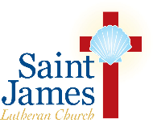
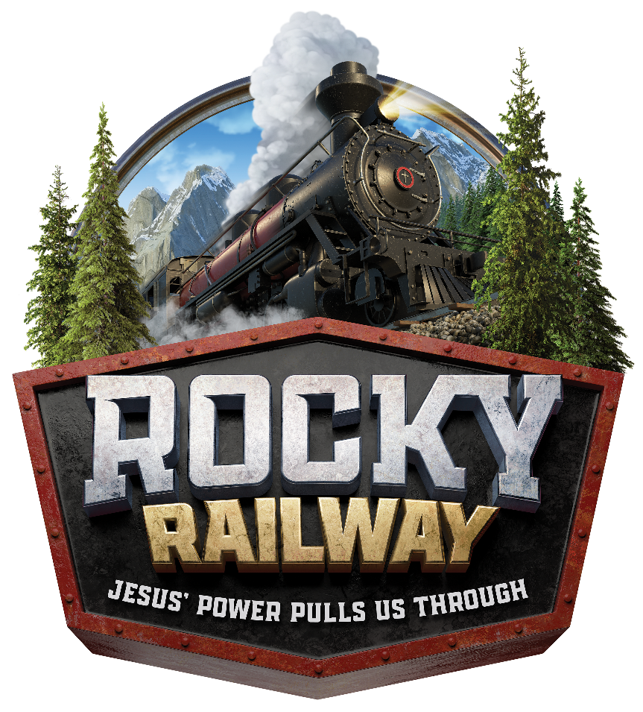
VBS 2021
$70 per child
August 2-6, 2021
9am-12:15pm
Welcome to Rocky Railway – where Jesus’ power pulls us through! Each day your children will be part of fun Bible learning they can see, hear, touch, and even taste! Bible point crafts, team building games, lively Bible songs, and tasty treats are just a few of the activities that help children celebrate God’s love for them!
Little Kids Depot
3, 4, and 5 year olds
Preschoolers will be matched up in crews with other children ages 3, 4, and 5. Each small group will be led by volunteer helpers and share in age appropriate Bible adventures and games. Preschool children must have completed one year of preschool in order to register.
RAILROAD CREWS
Elementary: Completed K-5th Grades
Each child will be placed in RAILROAD CREWS. Each crew will include a volunteer leader who leads the group to stations of exciting crafts, amazing Bible adventures, and catchy songs. Come join us where Jesus’ power pulls us through!
VOLUNTEERS
All volunteers must have completed 8th grade!
8th graders who have participated in our program will be eligible to participate as “helpers.” 9th graders and above who have participated in our program will be eligible to participate as CREW LEADERS, CO-CREW LEADERS, and STATION WORKERS. And Parents, there is always a need for adult volunteers! Won’t you join us?
Child Volunteer: ____________________ Grade Completed: ___
Adult Volunteer: ________________________________
All volunteers must sign up before July 11th!
STJLC VBS 2021 – Registration Form
Child’s Name: ______________________________________________
Street Address: _____________________________________________
_____________________________________________
Mobile/Home Phone: _______________________________________
Email: ____________________________________________________
Child’s Date of Birth (MM/DD/YYYY): _______________________
Allergies: __________________________________________________
Emergency Contact Name: ___________________________________
Emergency Contact Phone: ___________________________________
If you’d like to request a specific crew placement with another child, please list name(s) here: ______________________________________
*please note that we cannot guarantee all crew placement requests
Grade Completed as of June 2021
(Please check one)
Little Kids Depot | Railroad Crews
- 3 year old preschool  - 4 year old preschool  Name of preschool attended:  _________________________ | - Kindergarten  - 1st Grade  - 2nd Grade  - 3rd Grade  - 4th Grade  - 5th Grade
*Sorry, registration fees are non-refundable. $70 registration fee includes a CD or Digital Download of Rocky Railway music to listen to at home! Please select which format you would like:
□ CD □ Digital Download
Registration Instructions
I’M NOT LYIN’ -FIRST COME, FIRST SERVED!
Return this form to:
Church office drop box at
230 Second Ave
Saint James, NY 11780
Attn: Karin Ryan, VBS Director
Checks Payable to:
Saint James Lutheran Church

THE DEADLINE IS JUNE 28th —NO EXCEPTIONS!
Please direct any questions or concerns to Karin Ryan, VBS Director, at karinryan1@yahoo.com.

